TeenSelect 2023
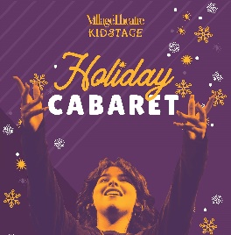
Holiday Cabaret
PREVIEW GUIDE
The show will run approximately 70 minutes with no intermission

The family-friendly Holiday Cabaret will consist of a compilation of songs from beloved holiday classics, movies, and musicals. Peppered with some choreography and a dash of irreverence, the Holiday Cabaret musical and dance numbers were curated to promote the warmth, love, and joy that comes from celebrating during the winter season.
The Holiday Cabaret is designed to bring people of all walks of life to celebrate together this holiday season.

Holiday Cabaret
Directed by  Adam Immerwahr | Music Directed by  Orlando Morales  & Rhyonna Rosales | Choreographed  & Associate Directed by  Mackenzie Malhotra

