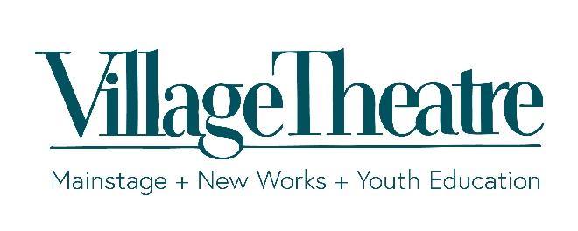
Village Theatre Use Only

Item #:

Package #:

Sing it forward Auction Item Donation Form

Donor or Company Name (as it will appear in catalog): | Donor Phone:
Donor Address (include city, state and zip): | Donor Email:
 | Contact Phone, if different than above:
 | Contact Email, if different than above:

Donated Item Information Catalog Deadline |  |  | Oct 1, 2022
Detailed Catalog Item Description: Please be complete (i.e., quantity, size, color, number of people, valid dates, all label information for wine, etc.) Please attach any additional information.

Restrictions: (Expiration date, date specific, tax and gratuity not included, etc.) |  |  |  | Item Value:  (Fair Market Value)  $
Type of Item  Physical Item  Certificate or Service  Combination Package | Certificate or Service Item  Gift certificate accompanies donation form  Gift certificate will be mailed to Village Theatre  Village Theatre has permission to create certificate  with my contact information on it. | Physical Item  Item will be delivered to Village  Theatre  Contact: Whitney Lewis  Tel: (425) 392-1942 ext. 151  Fax: (425) 391-3242  Email: wlewis@villagetheatre.org  Please pick up my donation
Village Theatre Contact: Danielle Franich, Associate Advancement Director
303 Front St N. Ph: (425) 392-1942 x116
Issaquah, WA 98027 Please email completed form and company logo to:
Village Theatre Tax ID#: 91-1077130 dfranich@villagetheatre.org

