Checklist before attending a Remo Event
Follow this checklist to get you and your computer Remo ready!
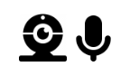
- To get the full networking experience use a computer with a camera and microphone. It is not required but will let you have an amazing experience!
- Browser and Operating System (OS) Compatibility:
As we use the latest video technology, make sure your browser and operating system (OS) is updated to the latest version. Please check that you are using a compatible browser and operating system (OS) that fulfils the versions listed in the table below.

OS | OS Version | Browser | Browser Version
Mac | 10.13+ | Chrome | 77+
 |  | Firefox | 76+
 | 10.14.4+ | Safari | 12.1+ (No screen share)  13+ (Full compatibility)
 |  | Chrome | 77+
 |  | Firefox | 76+
Windows | 10 | Chrome | 77+
 |  | Firefox | 76+
Click here to check your OS and browser version.
  - Remo currently only supports Chrome, Safari, or Firefox browser on your desktop/laptop computer.
  - Mobile phone and tablets are not supported in Remo.
- Before the event, check that your microphone and camera works and that your browser, hardware and internet connection fulfills our requirements on this test page.
  - If your camera or microphone does not work here are some troubleshooting guides to help you resolve common issues:
My camera and microphone does not work on Windows 10
My camera and microphone does not work on MacOSX
  - If your camera or microphone still does not work, go here live.remo.co and click on the "Need Help" button on the bottom left corner.
- Locate yourself in a quiet place with a non-distracting background before you enter the event
- Watch this YouTube video for instructions on how to use Remo.
- Go to the link that was sent to you and register with your name, email, and password.
- Most importantly have fun and enjoy a great event!

I’m logged in, now what?
- Now the fun begins! When you first log in to the event you were invited to, Remo will place you at a random table with other guests. You’ll have to turn on your camera and microphone so the other guests can see and hear you.
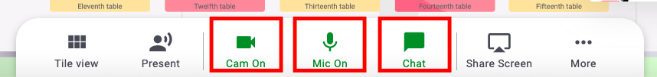
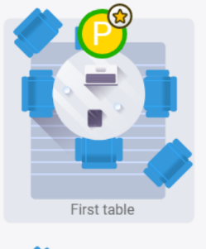
- If you aren’t sure what table you are at currently, look for your circular icon on the map. It will either be a bright color circle with your first initial, or your photo if you uploaded a profile picture.
- If you’d like to move tables, just double click on any open seat and you’ll be automatically brought to that new table.
- If you are looking for a particular guest or group of friends, there are a couple ways to find them. You can find their name in the Chat feature, and directly message them to ask where they are. Or you can visually scan the tables on your floor for their icon. You may have to go to another floor to find them.

How to Move Around the Room
- Join a table by double clicking on any open seat at a table or seating area
- Click and drag to look around the room to find an open seat.
- When you are ready to move to a new table, bid farewell to your tablemates and double click on another open seat.
- You can continue exploring by using the Elevator on the left of the room to visit other floors.
- Change your view by click on the button on your white menu bar in the bottom center of your screen.
  - Depending on the view you are currently in, you can change to “tile view” or “back to map” .

How to Update Your Guest Profile
- Click on your image/image icon in the right-hand corner
- From the drop-down menu select 'My Profile'
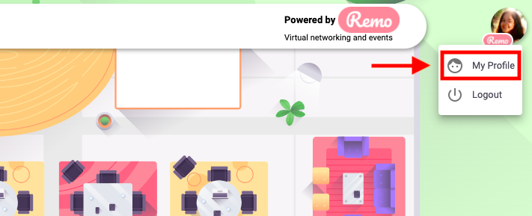
- Once on your profile page, click the 'Edit Profile' button
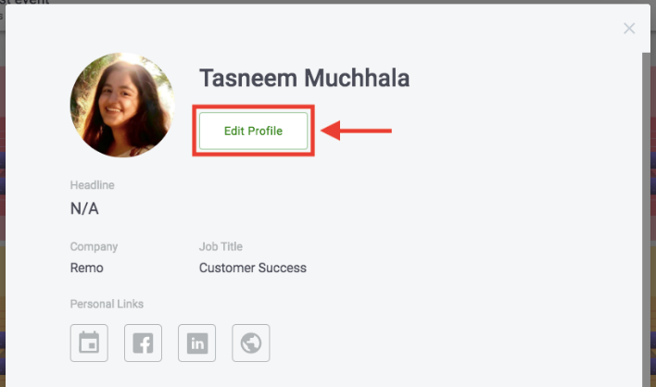
- To edit your profile you can:
  - Add your Full Name
  - Add a Profile Picture
  - Add a Headline and your Job Title
  - Add a URL to schedule meetings, e.g. a Calendly link
  - Connect to your LinkedIn or Facebook Profiles
  - Add a link to your Website (you can use this to link to your Instagram if you wish!)
- Once you've filled everything you want, make sure to click 'Save Changes' at the bottom of the page
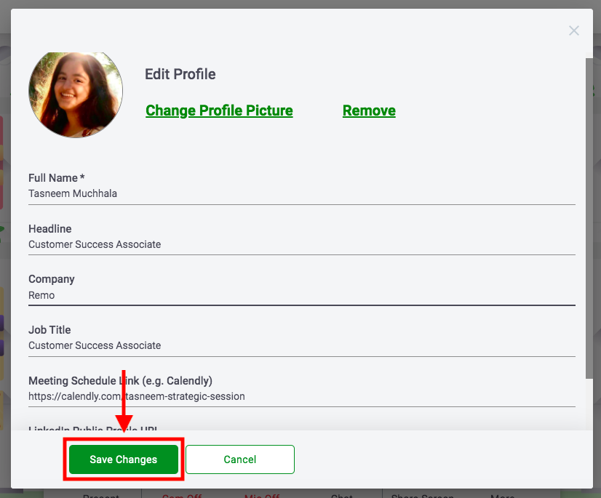
- Check out this short video walk-through for updating your profile.

How to Connect with People During the Event
There are a number of ways you can connect with other guests in Remo:
- Switch your camera and microphone on! This will allow you to video chat with the other guests at your table, which is all the fun of Remo.
- If you are having issues with your microphone or camera, please check out this test page
- Online chat - You can choose to chat with...
  - General Chat: All other guests
  - Table Chat: Those only on your table
  - Private Message: 1:1 direct message with another guest
  - Check out this article for the differences in the above types of chats
- Connect with guests on LinkedIn or Facebook or via their website
To do this, all you need to do is click a user's profile image and the following pop-up will appear.
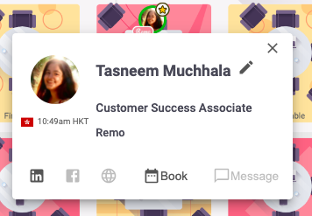
- You can now experience Remo with the above powerful features for networking. Enjoy! ✨

